**The University of Lahore, CS & IT Department**

**Programming Fundamentals**

**Assignment # 04**

**Start Date:** 06/01/2025 **Section: 2-I Total Marks: 20**

**Due Date:** 07/01/2025 **Program:** BSCS

**Instructions**

1. Understanding the problems is part of the assignment. So, no query, please.
2. You will get zero marks if found any type of plagiarism.
3. No submission after due date.
4. Upload pdf file containing your code and screenshots of outputs.

**Q1:** Write a C++ program that accepts a SAP ID and an email address from the user. The email address must meet certain conditions based on whether the last digit of the SAP ID is even or odd.

* If the last digit is even or zero, the email must contain the "@" symbol and at least one dot (".") after the "@".
* If the last digit is odd, the email must contain the "@" symbol and should not have an underscore ("_").

Implement two functions to check the validity of the email address based on the SAP ID condition. The program should display specific error messages for each condition that is not met and prompt the user to enter a valid email address. The program should repeat this process until a valid email address is entered.

Note:

* Use arrays, functions, and while loop to fulfill the conditions and validate the email address.
* Do not use pointers in the program.
* Sample output snap is attached.

1. When SAP ID last digit is odd.

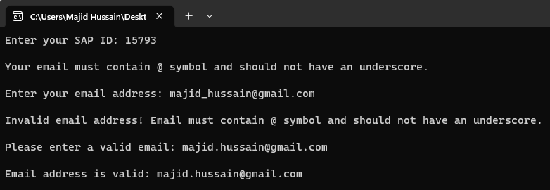

1. When SAP ID last digit is even or zero.

